**8/26/2025**

1. We have redesigned Table 1 (ER Visit), and Table 2 to Table 5 (Drugs Consumption), using landscape layout:
   1. We found that the 'rate' could not be calculated directly from the per_capita values in the raw data, since those values represent daily rather than annual figures. To avoid miscalculation, we instead calculated the rate by summing the total ER visits and dividing by the population for each year.
   2. We added a population column for each year to avoid ambiguity.
   3. We replaced the rate calculation from per 1,000,000 residents to per 1,000 residents to keep the numbers concise and easy to read.
2. We updated all spatiotemporal figures for ER visits and drug consumption to include both total counts and per capita rates (Figures 11–20). Because the per capita analyses revealed clearer spatial and temporal patterns, we provided brief interpretations for the corresponding figures (Figures 12, 17, 18, 19, and 20).

**8/24/2025**

1. Pc to Rate in table 1, Replace the average population with that of 2019
2. Add GLMM interaction, see page 20.
3. offset is set as population, instead of log_population (see page 21). The result is same to which used log_pop.
4. top 5 in GLMM report

**1. Descriptive Statistics**

***1.1 Annual ER Opioid-Related Visits Analysis***

***1.2 Annual Drug Consumption***

**Table 1.**

Summary of ER Opioid-Related Visits (Counts and Rates per 1,000 Residents) by County and Year (2016–2019)

|  |  |  |  |  |  |  |  |  |  |  |  |  |  |  |
| --- | --- | --- | --- | --- | --- | --- | --- | --- | --- | --- | --- | --- | --- | --- |
| County |  | 2016 |  |  | 2017 |  |  | 2018 |  |  | 2018 |  | Total | Avg  Rate |
| Population | Visit | Rate | Population | Visit | Rate | Population | Visit | Rate | Population | Visit | Rate |
| BLOUNT | 57494 | 102 | 1.77 | 57787 | 94 | 1.63 | 57771 | 58 | 1.00 | 57826 | 42 | 0.73 | 296 | 1.28 |
| CHEROKEE | 25768 | 10 | 0.39 | 25805 | 19 | 0.74 | 26014 | 39 | 1.50 | 26196 | 75 | 2.86 | 143 | 1.37 |
| COLBERT | 54497 | 52 | 0.95 | 54695 | 86 | 1.57 | 55004 | 61 | 1.11 | 55241 | 134 | 2.43 | 333 | 1.52 |
| CULLMAN | 82450 | 53 | 0.64 | 82867 | 67 | 0.81 | 83418 | 59 | 0.71 | 83768 | 52 | 0.62 | 231 | 0.70 |
| ETOWAH | 102855 | 32 | 0.31 | 103007 | 36 | 0.35 | 102611 | 80 | 0.78 | 102268 | 124 | 1.21 | 272 | 0.66 |
| FAYETTE | 16563 | 25 | 1.51 | 16466 | 20 | 1.21 | 16445 | 18 | 1.09 | 16302 | 11 | 0.67 | 74 | 1.12 |
| FRANKLIN | 31611 | 37 | 1.17 | 31542 | 59 | 1.87 | 31298 | 37 | 1.18 | 31362 | 94 | 3.00 | 227 | 1.80 |
| JACKSON | 51988 | 12 | 0.23 | 51828 | 17 | 0.33 | 51621 | 21 | 0.41 | 51626 | 12 | 0.23 | 62 | 0.30 |
| JEFFERSON | 660343 | 567 | 0.86 | 659599 | 544 | 0.82 | 659429 | 583 | 0.88 | 658573 | 565 | 0.86 | 2259 | 0.86 |
| LAMAR | 13928 | - | - | 13882 | - | - | 13882 | - | - | 13805 | - | - | 33 | 0.60 |
| LAUDERDALE | 92425 | 28 | 0.30 | 92564 | 35 | 0.38 | 92604 | 43 | 0.46 | 92729 | 160 | 1.73 | 266 | 0.72 |
| LAWRENCE | 33227 | 26 | 0.78 | 33063 | 38 | 1.15 | 32941 | 27 | 0.82 | 32924 | 55 | 1.67 | 146 | 1.10 |
| LIMESTONE | 92847 | 57 | 0.61 | 94130 | 62 | 0.66 | 96177 | 31 | 0.32 | 98915 | 35 | 0.35 | 185 | 0.48 |
| MADISON | 356729 | 302 | 0.85 | 361762 | 471 | 1.3 | 367004 | 279 | 0.76 | 372909 | 118 | 0.32 | 1170 | 0.81 |
| MARION | 29960 | 17 | 0.57 | 29792 | 23 | 0.77 | 29750 | 28 | 0.94 | 29709 | 32 | 1.08 | 100 | 0.84 |
| MARSHALL | 95113 | 79 | 0.83 | 95572 | 81 | 0.85 | 96170 | 38 | 0.40 | 96774 | 16 | 0.17 | 214 | 0.56 |
| MORGAN | 119006 | 79 | 0.66 | 118918 | 93 | 0.78 | 119203 | 90 | 0.76 | 119679 | 57 | 0.48 | 319 | 0.67 |
| PICKENS | 20325 | - | - | 20204 | - | - | 19980 | - | - | 19930 | - | - | 23 | 0.29 |
| SHELBY | 211282 | 147 | 0.70 | 213633 | 118 | 0.55 | 215583 | 129 | 0.60 | 217702 | 143 | 0.66 | 537 | 0.63 |
| TUSCALOOSA | 206464 | 91 | 0.44 | 207618 | 87 | 0.42 | 208319 | 51 | 0.24 | 209355 | 51 | 0.24 | 280 | 0.33 |
| WALKER | 64533 | 82 | 1.27 | 63895 | 85 | 1.33 | 63669 | 73 | 1.15 | 63521 | 69 | 1.09 | 309 | 1.21 |
| WINSTON | 23907 | 25 | 1.05 | 23760 | 20 | 0.84 | 23693 | 30 | 1.27 | 23629 | 34 | 1.44 | 109 | 1.15 |

*Note.* Pop = population; Visit = the total number of ER visits; Rate = the number of visits per 1,000 residents; “Total MME” is the sum over the study period; “Avg Rate” is the mean annual rate across the study period. Data for Lamar and Pickens counties are suppressed for individual years in accordance with CMS cell-size suppression policy (N < 10).

**Table 2.**

Summary of *Buprenorphine Consumption* (Counts and Rates per 1,000 Residents) by County and Year (2016–2019)

|  |  |  |  |  |  |  |  |  |  |  |  |  |  |  |
| --- | --- | --- | --- | --- | --- | --- | --- | --- | --- | --- | --- | --- | --- | --- |
| County |  | 2016 |  |  | 2017 |  |  | 2018 |  |  | 2019 |  | Total  MME | Avg Rate |
| Pop | MME | Rate | Pop | MME | Rate | Pop | MME | Rate | Pop | MME | Rate |
| BLOUNT | 57494 | 17626 | 0.31 | 57787 | 19353 | 0.33 | 57771 | 22927 | 0.40 | 57826 | 26663 | 0.46 | 86569 | 0.38 |
| CHEROKEE | 25768 | 11760 | 0.46 | 25805 | 11531 | 0.45 | 26014 | 16612 | 0.64 | 26196 | 18060 | 0.69 | 57963 | 0.56 |
| COLBERT | 54497 | 42670 | 0.78 | 54695 | 56494 | 1.03 | 55004 | 55728 | 1.01 | 55241 | 69080 | 1.25 | 223972 | 1.02 |
| CULLMAN | 82450 | 55676 | 0.68 | 82867 | 61611 | 0.74 | 83418 | 71185 | 0.85 | 83768 | 79748 | 0.95 | 268220 | 0.80 |
| ETOWAH | 102855 | 123162 | 1.20 | 103007 | 159932 | 1.55 | 102611 | 165869 | 1.62 | 102268 | 179131 | 1.75 | 628094 | 1.53 |
| FAYETTE | 16563 | 1628 | 0.10 | 16466 | 2015 | 0.12 | 16445 | 2577 | 0.16 | 16302 | 4673 | 0.29 | 10893 | 0.17 |
| FRANKLIN | 31611 | 28842 | 0.91 | 31542 | 35520 | 1.13 | 31298 | 38186 | 1.22 | 31362 | 43348 | 1.38 | 145896 | 1.16 |
| JACKSON | 51988 | 11000 | 0.21 | 51828 | 12389 | 0.24 | 51621 | 12417 | 0.24 | 51626 | 15515 | 0.30 | 51321 | 0.25 |
| JEFFERSON | 660343 | 658068 | 1.00 | 659599 | 666919 | 1.01 | 659429 | 721680 | 1.09 | 658573 | 786097 | 1.19 | 2832764 | 1.07 |
| LAMAR | 13928 | 3480 | 0.25 | 13882 | 4652 | 0.34 | 13882 | 6637 | 0.48 | 13805 | 9162 | 0.66 | 23931 | 0.43 |
| LAUDERDALE | 92425 | 45168 | 0.49 | 92564 | 44529 | 0.48 | 92604 | 50442 | 0.54 | 92729 | 54119 | 0.58 | 194258 | 0.52 |
| LAWRENCE | 33227 | 9617 | 0.29 | 33063 | 11139 | 0.34 | 32941 | 13731 | 0.42 | 32924 | 16928 | 0.51 | 51415 | 0.39 |
| LIMESTONE | 92847 | 84878 | 0.91 | 94130 | 105842 | 1.12 | 96177 | 115263 | 1.20 | 98915 | 119296 | 1.21 | 425279 | 1.11 |
| MADISON | 356729 | 191812 | 0.54 | 361762 | 212388 | 0.59 | 367004 | 237907 | 0.65 | 372909 | 257626 | 0.69 | 899733 | 0.62 |
| MARION | 29960 | 49063 | 1.64 | 29792 | 61106 | 2.05 | 29750 | 74565 | 2.51 | 29709 | 83387 | 2.81 | 268121 | 2.25 |
| MARSHALL | 95113 | 95296 | 1.00 | 95572 | 139422 | 1.46 | 96170 | 165555 | 1.72 | 96774 | 187752 | 1.94 | 588025 | 1.53 |
| MORGAN | 119006 | 156032 | 1.31 | 118918 | 125985 | 1.06 | 119203 | 144972 | 1.22 | 119679 | 190193 | 1.59 | 617182 | 1.29 |
| PICKENS | 20325 | 2353 | 0.12 | 20204 | 2083 | 0.10 | 19980 | 2562 | 0.13 | 19930 | 4924 | 0.25 | 11922 | 0.15 |
| SHELBY | 211282 | 142500 | 0.67 | 213633 | 157709 | 0.74 | 215583 | 170082 | 0.79 | 217702 | 172529 | 0.79 | 642820 | 0.75 |
| TUSCALOOSA | 206464 | 39402 | 0.19 | 207618 | 44540 | 0.21 | 208319 | 55405 | 0.27 | 209355 | 71680 | 0.34 | 211027 | 0.25 |
| WALKER | 64533 | 95430 | 1.48 | 63895 | 118203 | 1.85 | 63669 | 152011 | 2.39 | 63521 | 168750 | 2.66 | 534394 | 2.10 |
| WINSTON | 23907 | 29300 | 1.23 | 23760 | 35728 | 1.50 | 23693 | 47545 | 2.01 | 23629 | 47740 | 2.02 | 160313 | 1.69 |

*Note.* Pop = population; MME = morphine milligram equivalents; Rate = MME per 1,000 residents); “Total MME” is the sum over the study period, and “Avg Rate” is the average per capita MME across years.

**Table 3.**

Summary of Hydrocodone Consumption (Counts and Rates per 1,000 Residents) by County and Year (2016–2019)

|  |  |  |  |  |  |  |  |  |  |  |  |  |  |  |
| --- | --- | --- | --- | --- | --- | --- | --- | --- | --- | --- | --- | --- | --- | --- |
| County |  | 2016 |  |  | 2017 |  |  | 2018 |  |  | 2019 |  | Total  MME | Avg Rate |
| Pop | MME | Rate | Pop | MME | Rate | Pop | MME | Rate | Pop | MME | Rate |
| BLOUNT | 57494 | 6418 | 0.11 | 57787 | 5422 | 0.09 | 57771 | 5295 | 0.09 | 57826 | 3823 | 0.07 | 20958 | 0.09 |
| CHEROKEE | 25768 | 7276 | 0.28 | 25805 | 6669 | 0.26 | 26014 | 6361 | 0.24 | 26196 | 5839 | 0.22 | 26145 | 0.25 |
| COLBERT | 54497 | 25481 | 0.47 | 54695 | 23836 | 0.44 | 55004 | 21634 | 0.39 | 55241 | 20036 | 0.36 | 90987 | 0.42 |
| CULLMAN | 82450 | 24404 | 0.30 | 82867 | 21091 | 0.25 | 83418 | 17763 | 0.21 | 83768 | 15033 | 0.18 | 78291 | 0.23 |
| ETOWAH | 102855 | 32419 | 0.32 | 103007 | 28592 | 0.28 | 102611 | 27166 | 0.26 | 102268 | 24783 | 0.24 | 112960 | 0.28 |
| FAYETTE | 16563 | 2642 | 0.16 | 16466 | 2240 | 0.14 | 16445 | 1850 | 0.11 | 16302 | 1705 | 0.10 | 8437 | 0.13 |
| FRANKLIN | 31611 | 13891 | 0.44 | 31542 | 10680 | 0.34 | 31298 | 8816 | 0.28 | 31362 | 8567 | 0.27 | 41954 | 0.33 |
| JACKSON | 51988 | 16857 | 0.32 | 51828 | 15272 | 0.29 | 51621 | 13139 | 0.25 | 51626 | 11804 | 0.23 | 57072 | 0.27 |
| JEFFERSON | 660343 | 147753 | 0.22 | 659599 | 130476 | 0.20 | 659429 | 114637 | 0.17 | 658573 | 101339 | 0.15 | 494205 | 0.18 |
| LAMAR | 13928 | 2637 | 0.19 | 13882 | 2262 | 0.16 | 13882 | 2010 | 0.14 | 13805 | 1758 | 0.13 | 8667 | 0.16 |
| LAUDERDALE | 92425 | 20191 | 0.22 | 92564 | 17901 | 0.19 | 92604 | 15380 | 0.17 | 92729 | 13822 | 0.15 | 67294 | 0.18 |
| LAWRENCE | 33227 | 7028 | 0.21 | 33063 | 5442 | 0.16 | 32941 | 4971 | 0.15 | 32924 | 4459 | 0.14 | 21900 | 0.16 |
| LIMESTONE | 92847 | 15429 | 0.17 | 94130 | 14408 | 0.15 | 96177 | 13368 | 0.14 | 98915 | 12122 | 0.12 | 55327 | 0.15 |
| MADISON | 356729 | 67528 | 0.19 | 361762 | 60335 | 0.17 | 367004 | 50964 | 0.14 | 372909 | 44007 | 0.12 | 222834 | 0.16 |
| MARION | 29960 | 12147 | 0.41 | 29792 | 10636 | 0.36 | 29750 | 9709 | 0.33 | 29709 | 8551 | 0.29 | 41043 | 0.35 |
| MARSHALL | 95113 | 35326 | 0.37 | 95572 | 32146 | 0.34 | 96170 | 29526 | 0.31 | 96774 | 26429 | 0.27 | 123427 | 0.32 |
| MORGAN | 119006 | 29591 | 0.25 | 118918 | 26374 | 0.22 | 119203 | 24033 | 0.20 | 119679 | 20885 | 0.17 | 100883 | 0.21 |
| PICKENS | 20325 | 3395 | 0.17 | 20204 | 2979 | 0.15 | 19980 | 2660 | 0.13 | 19930 | 2302 | 0.12 | 11336 | 0.14 |
| SHELBY | 211282 | 31296 | 0.15 | 213633 | 28289 | 0.13 | 215583 | 25405 | 0.12 | 217702 | 22791 | 0.10 | 107781 | 0.12 |
| TUSCALOOSA | 206464 | 37124 | 0.18 | 207618 | 33104 | 0.16 | 208319 | 28856 | 0.14 | 209355 | 25389 | 0.12 | 124473 | 0.15 |
| WALKER | 64533 | 28174 | 0.44 | 63895 | 24613 | 0.39 | 63669 | 22647 | 0.36 | 63521 | 20105 | 0.32 | 95539 | 0.38 |
| WINSTON | 23907 | 8469 | 0.35 | 23760 | 7874 | 0.33 | 23693 | 7043 | 0.30 | 23629 | 6100 | 0.26 | 29486 | 0.31 |

*Note.* Pop = population; MME = morphine milligram equivalents; Rate = MME per 1,000 residents); “Total MME” is the sum over the study period, and “Avg Rate” is the average per capita MME across years.

**Table 4.**

Summary of Methadone Consumption (Counts and Rates per 1,000 Residents) by County and Year (2016–2019)

|  |  |  |  |  |  |  |  |  |  |  |  |  |  |  |
| --- | --- | --- | --- | --- | --- | --- | --- | --- | --- | --- | --- | --- | --- | --- |
| County |  | 2016 |  |  | 2017 |  |  | 2018 |  |  | 2019 |  | Total  MME | Avg Rate |
| Pop | MME | Rate | Pop | MME | Rate | Pop | MME | Rate | Pop | MME | Rate |
| BLOUNT | 57494 | 1436 | 0.02 | 57787 | 1450 | 0.03 | 57771 | 1347 | 0.02 | 57826 | 1078 | 0.02 | 5311 | 0.02 |
| CHEROKEE | 25768 | 2304 | 0.09 | 25805 | 767 | 0.03 | 26014 | 781 | 0.03 | 26196 | 431 | 0.02 | 4283 | 0.04 |
| COLBERT | 54497 | 6888 | 0.13 | 54695 | 4858 | 0.09 | 55004 | 4223 | 0.08 | 55241 | 3450 | 0.06 | 19419 | 0.09 |
| CULLMAN | 82450 | 11476 | 0.14 | 82867 | 8037 | 0.10 | 83418 | 5810 | 0.07 | 83768 | 3780 | 0.05 | 29103 | 0.09 |
| ETOWAH | 102855 | 19475 | 0.19 | 103007 | 10421 | 0.10 | 102611 | 8285 | 0.08 | 102268 | 6763 | 0.07 | 44944 | 0.11 |
| FAYETTE | 16563 | 3913 | 0.24 | 16466 | 3531 | 0.21 | 16445 | 2770 | 0.17 | 16302 | 2406 | 0.15 | 12620 | 0.19 |
| FRANKLIN | 31611 | 2308 | 0.07 | 31542 | 1577 | 0.05 | 31298 | 1125 | 0.04 | 31362 | 757 | 0.02 | 5767 | 0.05 |
| JACKSON | 51988 | 1698 | 0.03 | 51828 | 1488 | 0.03 | 51621 | 1030 | 0.02 | 51626 | 660 | 0.01 | 4876 | 0.02 |
| JEFFERSON | 660343 | 52743 | 0.08 | 659599 | 43743 | 0.07 | 659429 | 33470 | 0.05 | 658573 | 24959 | 0.04 | 154915 | 0.06 |
| LAMAR | 13928 | 1625 | 0.12 | 13882 | 1467 | 0.11 | 13882 | 1544 | 0.11 | 13805 | 1556 | 0.11 | 6192 | 0.11 |
| LAUDERDALE | 92425 | 4268 | 0.05 | 92564 | 2982 | 0.03 | 92604 | 2541 | 0.03 | 92729 | 2349 | 0.03 | 12140 | 0.04 |
| LAWRENCE | 33227 | 1065 | 0.03 | 33063 | 1049 | 0.03 | 32941 | 998 | 0.03 | 32924 | 591 | 0.02 | 3703 | 0.03 |
| LIMESTONE | 92847 | 2703 | 0.03 | 94130 | 1992 | 0.02 | 96177 | 1796 | 0.02 | 98915 | 2354 | 0.02 | 8845 | 0.02 |
| MADISON | 356729 | 12935 | 0.04 | 361762 | 10322 | 0.03 | 367004 | 7335 | 0.02 | 372909 | 5509 | 0.01 | 36101 | 0.03 |
| MARION | 29960 | 4774 | 0.16 | 29792 | 3169 | 0.11 | 29750 | 2506 | 0.08 | 29709 | 2163 | 0.07 | 12612 | 0.11 |
| MARSHALL | 95113 | 11042 | 0.12 | 95572 | 6626 | 0.07 | 96170 | 4879 | 0.05 | 96774 | 3830 | 0.04 | 26377 | 0.07 |
| MORGAN | 119006 | 4073 | 0.03 | 118918 | 3548 | 0.03 | 119203 | 2692 | 0.02 | 119679 | 2068 | 0.02 | 12381 | 0.03 |
| PICKENS | 20325 | 2026 | 0.10 | 20204 | 1570 | 0.08 | 19980 | 1527 | 0.08 | 19930 | 1576 | 0.08 | 6699 | 0.09 |
| SHELBY | 211282 | 15207 | 0.07 | 213633 | 11812 | 0.06 | 215583 | 9133 | 0.04 | 217702 | 7698 | 0.04 | 43850 | 0.05 |
| TUSCALOOSA | 206464 | 39343 | 0.19 | 207618 | 35545 | 0.17 | 208319 | 30897 | 0.15 | 209355 | 25948 | 0.12 | 131733 | 0.16 |
| WALKER | 64533 | 18778 | 0.29 | 63895 | 13912 | 0.22 | 63669 | 11363 | 0.18 | 63521 | 8792 | 0.14 | 52845 | 0.21 |
| WINSTON | 23907 | 3087 | 0.13 | 23760 | 2546 | 0.11 | 23693 | 1701 | 0.07 | 23629 | 1427 | 0.06 | 8761 | 0.09 |

*Note.* Pop = population; MME = morphine milligram equivalents; Rate = MME per 1,000 residents); “Total MME” is the sum over the study period, and “Avg Rate” is the average per capita MME across years.

**Table 5.**

Summary of Oxycodone Consumption (Counts and Rates per 1,000 Residents) by County and Year (2016–2019)

|  |  |  |  |  |  |  |  |  |  |  |  |  |  |  |
| --- | --- | --- | --- | --- | --- | --- | --- | --- | --- | --- | --- | --- | --- | --- |
| County |  | 2016 |  |  | 2017 |  |  | 2018 |  |  | 2019 |  | Total  MME | Avg Rate |
| Pop | MME | Rate | Pop | MME | Rate | Pop | MME | Rate | Pop | MME | Rate |
| BLOUNT | 57494 | 8968 | 0.16 | 57787 | 8132 | 0.14 | 57771 | 8003 | 0.14 | 57826 | 7230 | 0.13 | 32333 | 0.14 |
| CHEROKEE | 25768 | 14523 | 0.56 | 25805 | 11994 | 0.46 | 26014 | 11096 | 0.43 | 26196 | 10029 | 0.38 | 47642 | 0.46 |
| COLBERT | 54497 | 31913 | 0.59 | 54695 | 25494 | 0.47 | 55004 | 19393 | 0.35 | 55241 | 16659 | 0.30 | 93459 | 0.43 |
| CULLMAN | 82450 | 34239 | 0.42 | 82867 | 30803 | 0.37 | 83418 | 24771 | 0.30 | 83768 | 20753 | 0.25 | 110566 | 0.33 |
| ETOWAH | 102855 | 63516 | 0.62 | 103007 | 49825 | 0.48 | 102611 | 46211 | 0.45 | 102268 | 40961 | 0.40 | 200513 | 0.49 |
| FAYETTE | 16563 | 3959 | 0.24 | 16466 | 3323 | 0.20 | 16445 | 2738 | 0.17 | 16302 | 1946 | 0.12 | 11966 | 0.18 |
| FRANKLIN | 31611 | 14038 | 0.44 | 31542 | 10700 | 0.34 | 31298 | 8209 | 0.26 | 31362 | 7295 | 0.23 | 40242 | 0.32 |
| JACKSON | 51988 | 21755 | 0.42 | 51828 | 21736 | 0.42 | 51621 | 19681 | 0.38 | 51626 | 16860 | 0.33 | 80032 | 0.39 |
| JEFFERSON | 660343 | 210082 | 0.32 | 659599 | 182931 | 0.28 | 659429 | 158460 | 0.24 | 658573 | 137035 | 0.21 | 688508 | 0.26 |
| LAMAR | 13928 | 3240 | 0.23 | 13882 | 3324 | 0.24 | 13882 | 2836 | 0.20 | 13805 | 2689 | 0.19 | 12089 | 0.22 |
| LAUDERDALE | 92425 | 24176 | 0.26 | 92564 | 19682 | 0.21 | 92604 | 17315 | 0.19 | 92729 | 14574 | 0.16 | 75747 | 0.21 |
| LAWRENCE | 33227 | 9380 | 0.28 | 33063 | 7494 | 0.23 | 32941 | 6786 | 0.21 | 32924 | 5638 | 0.17 | 29298 | 0.22 |
| LIMESTONE | 92847 | 39738 | 0.43 | 94130 | 32782 | 0.35 | 96177 | 27684 | 0.29 | 98915 | 24831 | 0.25 | 125035 | 0.33 |
| MADISON | 356729 | 136148 | 0.38 | 361762 | 117519 | 0.32 | 367004 | 93982 | 0.26 | 372909 | 79978 | 0.21 | 427627 | 0.29 |
| MARION | 29960 | 21472 | 0.72 | 29792 | 19359 | 0.65 | 29750 | 15576 | 0.52 | 29709 | 13672 | 0.46 | 70079 | 0.59 |
| MARSHALL | 95113 | 44277 | 0.47 | 95572 | 37086 | 0.39 | 96170 | 32429 | 0.34 | 96774 | 29523 | 0.31 | 143315 | 0.38 |
| MORGAN | 119006 | 50208 | 0.42 | 118918 | 38349 | 0.32 | 119203 | 32947 | 0.28 | 119679 | 26834 | 0.22 | 148338 | 0.31 |
| PICKENS | 20325 | 3502 | 0.17 | 20204 | 3080 | 0.15 | 19980 | 2951 | 0.15 | 19930 | 2696 | 0.14 | 12229 | 0.15 |
| SHELBY | 211282 | 66686 | 0.32 | 213633 | 59896 | 0.28 | 215583 | 49193 | 0.23 | 217702 | 42107 | 0.19 | 217882 | 0.26 |
| TUSCALOOSA | 206464 | 44197 | 0.21 | 207618 | 40220 | 0.19 | 208319 | 36153 | 0.17 | 209355 | 31060 | 0.15 | 151630 | 0.18 |
| WALKER | 64533 | 52573 | 0.81 | 63895 | 45261 | 0.71 | 63669 | 41296 | 0.65 | 63521 | 35919 | 0.57 | 175049 | 0.69 |
| WINSTON | 23907 | 7998 | 0.33 | 23760 | 7595 | 0.32 | 23693 | 7404 | 0.31 | 23629 | 6723 | 0.28 | 29720 | 0.31 |

*Note.* Pop = population; MME = morphine milligram equivalents; Rate = MME per 1,000 residents); “Total MME” is the sum over the study period, and “Avg Rate” is the average per capita MME across years.











Figure 1.

Annually ER Opioid Visits by County

Figure 1(B).

Quarterly ER Opioid Visits by County

Figure 2. County-Level Trends in ER Opioid Visit Rates (per 100,000 Residents)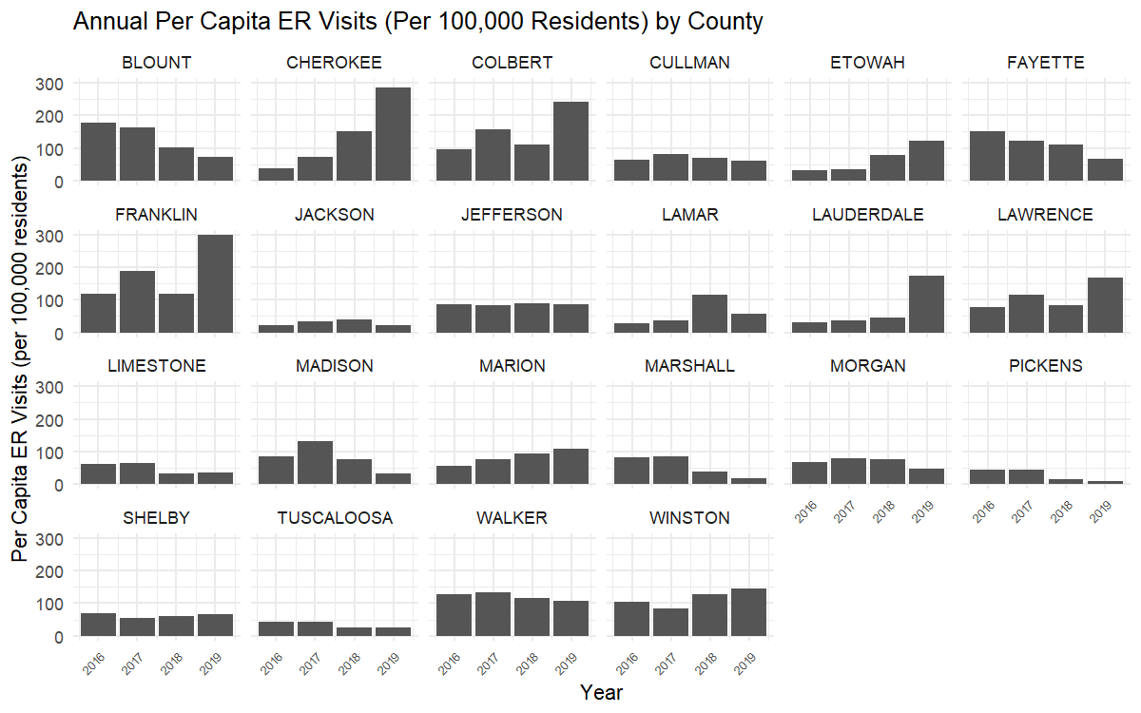

Figure 2 (B). Quarterly ER Opioid Visits Per Capita by County

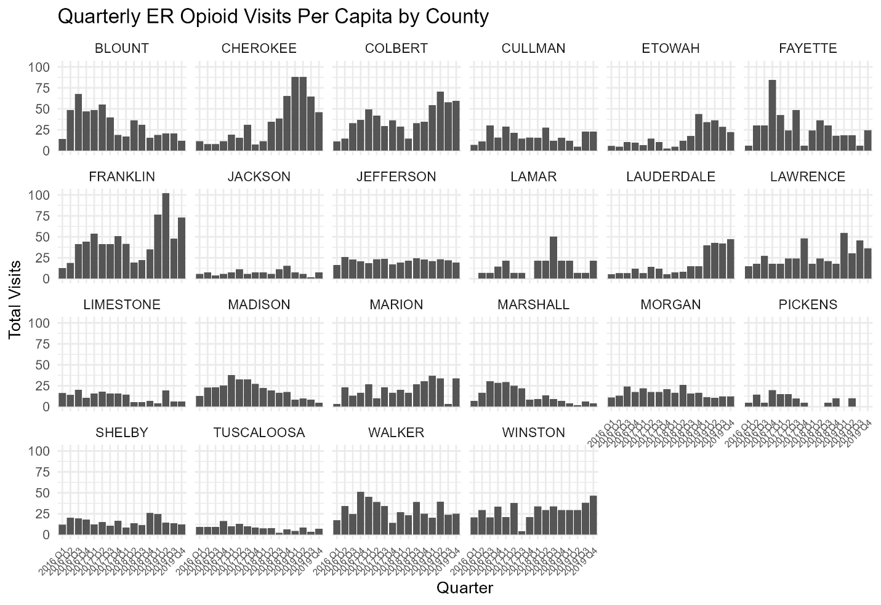

In Figure 1 and 2, Jefferson has consistently highest counts across all four years (about 500–600/year). Madison is second highest ER opioid count with a peak in 2017, followed by a sharp drop in 2019. Blount, Tuscaloosa, Limestone, and Marshall decrease ER opioid counts from 2016 to 2019, while Cherokee, Etowah, Lauderdale, and Marion show consistently increasing trends, requiring a future exploration on monthly scale. (Not report value less than 10, just not show, and keep reporting)

According to Figure 3, Cherokee exhibits a dramatical increase in ER opioid visits in September 2016 and keeps a high value (around 5 visits) until November 2017. Etowah demonstrates a similar pattern to Cherokee, with two peaks (around 20 visits) in October 2016 and April 2017, as well as a drop in November 2017. In contrast, although Lauderdale has increasing pattern in later 2016 and the whole of 2017, it has continued growth in November 2017. We will discuss the potential reason by collecting information and news at that time point.

***1.2 Medications Consumption Analysis***

**Figure 4.**

According to Figure 4, most counties exhibit a consistent increase in buprenorphine consumption over time, except Morgan and Pickens. These two counties display a distinct dip in 2017, forming a sharp trough in their otherwise upward trends.

In contrast to the increasing trend in buprenorphine consumption, hydrocodone, methadone, and oxycodone use demonstrates a consistent decline from 2016 to 2019 across all counties.

Figure 4 – 7 (B). Annual Medication Consumption Rate by County in MME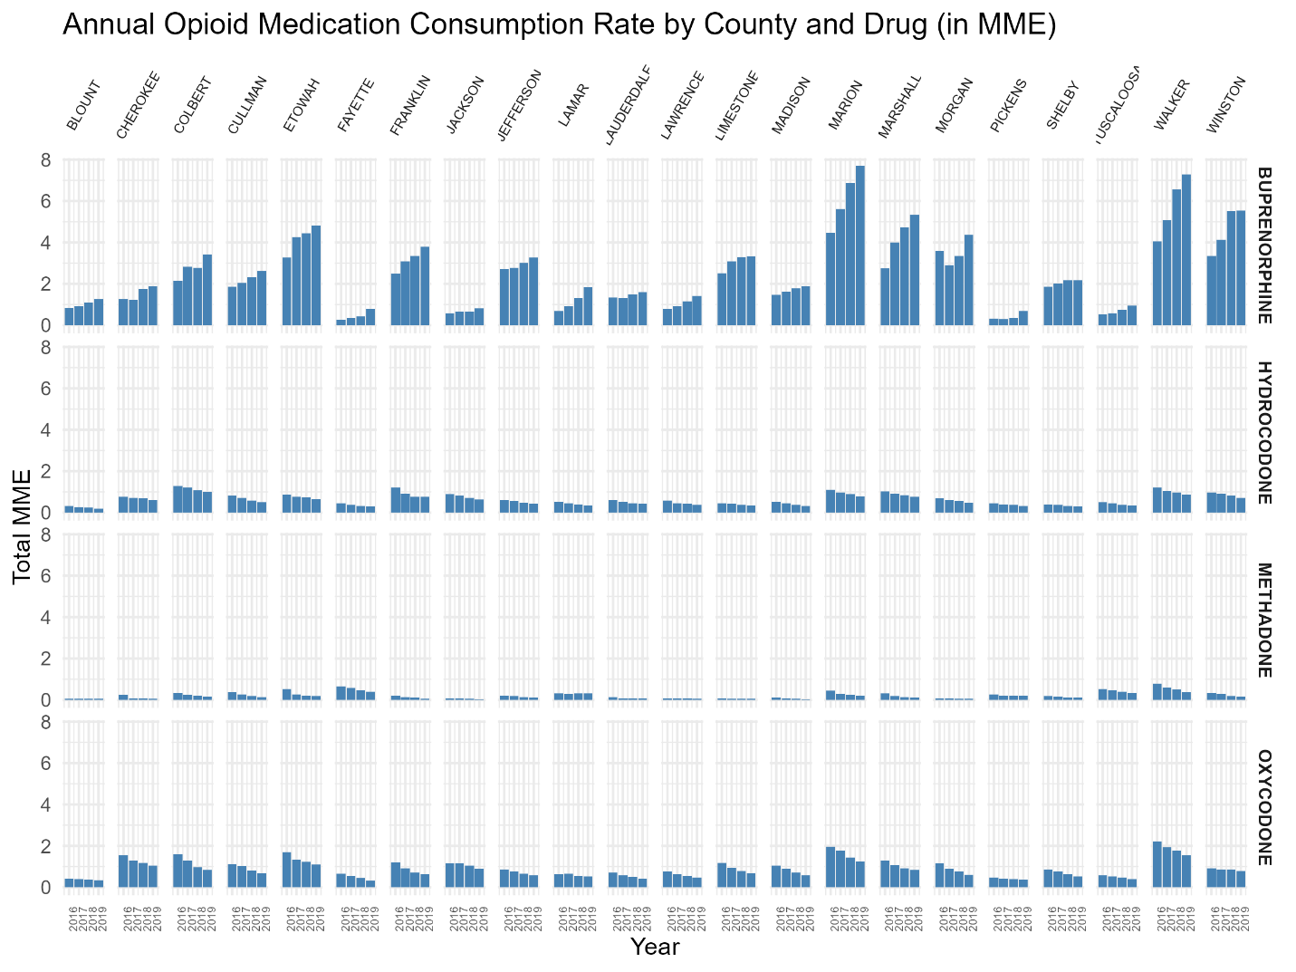



**2. Moran’s I and Hot Spot Analysis**

***2.1. Moran’s I and Hot Spot of ER Visits***

In this study, Moran’s I was calculated to measure the overall spatial clustering of ER visit counts and the consumption of four major opioid medications. The Moran’s I values for both total ER visits (0.089, *p* = 0.279) and per capita ER visits (0.206, *p* = 0.175) were not statistically significant. These results indicate an absence of strong spatial clustering patterns in ER opioid-related visits across the northwest Alabama region.

Figure 8. Hot Spot Analysis (Geti-Ord Gi*) of ER Visits (Per Capita)

In Figure 8 shows that Colbert, Franklin, and Lawrence counties exhibited increasing trends in ER visits, while Pickens and Madison counties demonstrated a decreasing pattern. Despite these localized variations, Moran’s I was not statistically significant for either total or per capita ER visits, indicating no strong spatial autocorrelation overall.

***2.2. Moran’s I and Hot Spot of Opioid Medication Consumption***

Table 2. Global Moran's I Summary of Medication Consumption (Total) for Counties in Northwest Alabama

|  |  |  |  |  |
| --- | --- | --- | --- | --- |
|  | **Buprenorphine** | **Hydrocodone** | **Methadone** | **Oxycodone** |
| Moran's Index | 0.188 | 0.070 | 0.048 | 0.192 |
| Expected Index | -0.048 | -0.048 | -0.048 | -0.048 |
| Variance | 0.013 | 0.017 | 0.026 | 0.023 |
| z-score | 2.036 | 0.898 | 0.591 | 1.584 |
| p-value | 0.042 | 0.369 | 0.554 | 0.113 |

Table 2 presents the results of Global Moran’s I analysis for the total consumption of four major opioid medications across counties in Northwest Alabama. Among the four drugs, only buprenorphine exhibited a statistically significant spatial autocorrelation, with a Moran’s I of 0.188 and a p-value of 0.042. This suggests a moderate positive spatial clustering of buprenorphine consumption—counties with high (or low) consumption are likely near other counties with similar levels. In contrast, hydrocodone, methadone, and oxycodone all showed non-significant Moran’s I values (p > 0.05), indicating that their consumption patterns were not significantly clustered across the region. These results imply that buprenorphine use may be influenced by localized factors, such as treatment access, provider availability, or targeted public health interventions, while the other drugs show a more diffuse or random spatial pattern in this region. Sequentially, the monthly Buprenorphine consumption and hot spot graph will be demonstrated for future study.

Table 3. Global Moran's I Summary of Medication Consumption (Per Capita) across Counties in Northwest Alabama

|  |  |  |  |  |
| --- | --- | --- | --- | --- |
|  | **Buprenorphine** | **Hydrocodone** | **Methadone** | **Oxycodone** |
| Moran's Index | 0.088832 | 0.062552 | 0.455197 | -0.072075 |
| Expected Index | -0.047619 | -0.047619 | -0.047619 | -0.047619 |
| Variance | 0.035280 | 0.036123 | 0.033704 | 0.033338 |
| z-score | 0.726468 | 0.579659 | 2.738834 | -0.133944 |
| p-value | 0.467552 | 0.562144 | 0.006166 | 0.893447 |

In Table 3, Global Moran’s I results indicate limited spatial clustering of per capita opioid medication consumption across counties in Northwest Alabama. While Buprenorphine, Hydrocodone, and Oxycodone show low and statistically non-significant Moran’s I values (p > .05), suggesting random spatial patterns, Methadone exhibits a moderate positive spatial autocorrelation (Moran’s I = 0.455, p = 0.006). This suggests that counties with higher Methadone consumption tend to be geographically clustered, potentially reflecting regional treatment practices or availability differences. No significant clustering was observed for the other drugs.

Figure 10. Hot Spot Analysis (Geti-Ord Gi*) of Methadone Consumption (Per Capita)

Figure 10 illustrates the spatial clustering of methadone consumption per capita using Getis-Ord Gi* statistics. The results identify a significant hot spot in the southwestern portion of the region, particularly in Tuscaloosa, Fayette, Walker, and Lamar counties.

**3. Spatiotemporal Analysis**

**Figure 11.**

Opioid-Related ER Visits by County

Figure 11 displays that Jefferson and Shelby counties consistently report the highest number of visits each year, which is likely related to their large populations and urban centers. In contrast, rural counties such as Lamar, Fayette, and Marion report relatively low numbers of ER visits. While the overall spatial pattern remains stable across years, there are slight fluctuations in counties such as Madison, which exhibit localized increases in 2017 and decrease after that. These results suggest that the opioid crisis is not evenly distributed geographically, with urban areas bearing a disproportionate burden.

**Figure 12.**

Opioid-Related ER Visits Rate by County

Figure 12 reveals both stable patterns and localized surges. While the majority of counties maintained relatively consistent visit rates over time, several notable fluctuations emerged. Specifically, Franklin and Colbert counties experienced elevated rates in 2017 and 2018, suggesting localized increases in opioid-related incidents during those years. In 2019, Cherokee and Lawrence counties exhibited sharp increases, indicating emerging hotspots. These shifting patterns underscore the importance of geographically targeted public health responses and resource allocation to address the evolving nature of the opioid crisis at the county level.

**Figure 13.**

**Figure 14.**

Hydrocodone Consumption by County

**Figure 15.**

Methadone Consumption by County

**Figure 16.**

Oxycodone Consumption by County

**Figure 17.**

Buprenorphine Consumption Rate (Per Capita) by County

Figure 17 presents that several counties show notable changes over time. Winston, Marion, and Walker counties consistently report higher per capita buprenorphine consumption rates compared to surrounding areas, with peaks observed in 2018 and 2019. In contrast, Jefferson and Tuscaloosa counties, despite their large populations and higher absolute consumption totals, demonstrate relatively lower per capita rates. By 2019, localized increases are evident in counties such as Marshall and Lawrence, suggesting emerging hotspots of opioid treatment demand and potential shifts in prescribing or access to medication-assisted therapy.

**Figure 18.**

Hydrocodone Consumption Rate (Per Capita) by County

Figure 18 shows the hydrocodone consumption rate (per capita) across counties in Northwest Alabama from 2016 to 2019. The maps highlight persistent geographic differences: Marion, Winston, and Franklin counties consistently reported higher per capita hydrocodone use compared to surrounding areas, with especially elevated rates in 2016 and 2017. By contrast, counties such as Tuscaloosa, Pickens, and Shelby maintained relatively lower consumption rates throughout the study period. While overall hydrocodone use per capita declined gradually in most counties, localized peaks remain evident, suggesting differing prescribing practices or healthcare access across the region.

**Figure 19.**

Methadone Consumption Rate (Per Capita) by County

Figure 19 illustrates that methadone use remained relatively low and spatially concentrated. In 2016, elevated rates were observed in counties such as Walker and Fayette, indicating localized reliance on methadone treatments during that year. By 2017 and 2018, these concentrations diminished slightly but persisted in Walker and neighboring areas, suggesting sustained but modest methadone distribution. In 2019, the pattern shifted further, with most counties exhibiting relatively stable or declining rates, while urban centers such as Jefferson and Tuscaloosa remained consistently low relative to their population size.

**Figure 20.**

Oxycodone Consumption Rate (Per Capita) by County

Figure 20 illustrates a consistent pattern of decreasing per capita consumption is observed in Walker and Marion counties, which stand out as areas with persistently higher rates compared to neighboring counties. These high values suggest localized demand or prescribing practices that maintain oxycodone consumption despite statewide efforts to regulate opioid use. Conversely, Jefferson and Tuscaloosa counties, despite their large populations and absolute consumption levels, display comparatively lower per capita rates, indicating that population size dilutes the rate of consumption. Notably, by 2019, oxycodone consumption rates generally stabilized or declined in many counties, but Walker and Winston continued to remain among the highest, highlighting potential ongoing hotspots for targeted public health intervention.

**Table X.**

AIC Comparison of Poisson and Negative Binomial Models with Varying Random Effects Structures

|  |  |  |  |
| --- | --- | --- | --- |
| **Model** | **AIC** | **pdHess** | **Description** |
| Inter_nb2 | **31477.02** | TRUE | Random intercept + random slope (County) + interaction between county and year, Negative Binomial (handles overdispersion) |
| Inter_pois | **31532.66** | TRUE | Random intercept + random slope (County) + interaction between county and year, Poisson |
| both_nb2 | **31588.52** | TRUE | Random intercept + random slope (County), Negative Binomial |
| both_pois | **31643.42** | TRUE | Random intercept + random slope (County), Poisson |
| sp_nb2 | **32052.32** | TRUE | Random intercept only (County), Negative Binomial |
| sp_pois | 32130.97 | TRUE | Random intercept only (County), Poisson |
| st_nb2 | 32358.58 | TRUE | Random slope only (County, no intercept RE), Negative Binomial |
| st_pois | 32450.94 | TRUE | Random slope only (County, no intercept RE), Poisson |
| glm_nb2 | 32859.61 | TRUE | GLM (no random effects), Negative Binomial |
| glm_pois | 32983.39 | TRUE | GLM (no random effects), Poisson |

*Note.* AIC = Akaike Information Criterion; lower values indicate better model fit. pdHess = Hessian positive-definite check, where TRUE indicates successful convergence. “Random intercept” models account for baseline differences between counties; “random slope” models account for county-specific temporal trends. Negative Binomial (nb2) models address overdispersion, while Poisson models assume the variance equals the mean.

Table X presents the AIC values for eight candidate models fitted to county-level counts, varying by distributional assumption (Poisson vs. Negative Binomial) and random effects structure. The model with the lowest AIC was the Negative Binomial model with both random intercept and random slope by county (AIC = 31,588.52), indicating the best balance of fit and parsimony among the tested models. This suggests that accounting for both baseline differences in county-level rates and heterogeneous year-to-year trends, while allowing for overdispersion, provides the most appropriate model for the data. Models assuming a Poisson distribution consistently performed worse, reflecting overdispersion in the counts. Simpler random effects structures (intercept-only or slope-only) and models without random effects (GLMs) also showed substantially higher AIC values, indicating poorer fit.

Table X.

Comparison of Spatiotemporal Models for County-Level Visit Counts

|  |  |  |  |
| --- | --- | --- | --- |
| **Model** | **Spatiotemporal Structure** | **AIC** | **Description** |
| fit_iid | IID (independent years) | 31,467.39 | Assumes annual spatiotemporal random effects are independent across years. |
| fit_ar1 | AR1 (first-order autoregressive) | 31,446.95 | Models correlation between random effects in consecutive years, allowing temporal persistence. |
| fit_rw | RW (random walk) | 31,448.63 | Models gradual changes in spatiotemporal random effects over time (smooth year-to-year drift). |

*Note.* AIC = Akaike Information Criterion.

Among the three, the AR1 model (AIC = 31,446.95, df = 7) demonstrated the best fit, with a decrease of 20.44 AIC units relative to the IID model (AIC = 31,467.39, df = 6) and a decrease of 1.68 AIC units relative to the RW model (AIC = 31,448.63, df = 6). These results suggest that incorporating temporal autocorrelation in the spatiotemporal random effects improves model fit over assuming independence across years.

Table X.

Baseline Rates and Annual Trends in Visits by County

|  |  |  |  |  |  |
| --- | --- | --- | --- | --- | --- |
| County | Intercept (log) | Slope (log/year) | Baseline rate  (/1M pop) | Annual multiplier | Annual change (%) |
| Lauderdale | -13.37 | 0.64 | 1.55 | 1.90 | 89.52 |
| Cherokee | -12.73 | 0.63 | 2.97 | 1.87 | 86.91 |
| Etowah | -13.35 | 0.48 | 1.59 | 1.62 | 61.80 |
| Franklin | -12.28 | 0.27 | 4.65 | 1.31 | 31.24 |
| Colbert | -12.44 | 0.27 | 3.94 | 1.30 | 30.41 |
| Lamar | -13.32 | 0.22 | 1.65 | 1.24 | 24.08 |
| Lawrence | -12.75 | 0.21 | 2.92 | 1.23 | 23.33 |
| Marion | -13.01 | 0.19 | 2.24 | 1.21 | 21.30 |
| Winston | -12.70 | 0.14 | 3.05 | 1.15 | 15.19 |
| Jackson | -13.95 | 0.01 | 0.87 | 1.01 | 0.91 |
| Jefferson | -12.96 | 0.01 | 2.34 | 1.01 | 0.79 |
| Shelby | -13.28 | -0.01 | 1.72 | 0.99 | -0.94 |
| Cullman | -13.17 | -0.02 | 1.90 | 0.98 | -2.12 |
| Walker | -12.63 | -0.05 | 3.27 | 0.95 | -5.31 |
| Morgan | -13.21 | -0.08 | 1.82 | 0.92 | -8.12 |
| Fayette | -12.75 | -0.20 | 2.91 | 0.82 | -18.18 |
| Limestone | -13.55 | -0.22 | 1.30 | 0.80 | -19.82 |
| Tuscaloosa | -13.92 | -0.22 | 0.90 | 0.80 | -20.00 |
| Madison | -13.07 | -0.28 | 2.11 | 0.76 | -24.26 |
| Blount | -12.62 | -0.29 | 3.30 | 0.75 | -25.09 |
| Pickens | -14.00 | -0.34 | 0.83 | 0.71 | -28.72 |
| Marshall | -13.50 | -0.44 | 1.36 | 0.64 | -35.73 |

*Note.* Intercept (log) represents the model-estimated log count at the baseline year for each county, adjusted for population size. Slope (log/year) is the estimated annual change in log count, indicating the direction and magnitude of trend over time. Baseline rate (/1M pop) converts the intercept into an estimated baseline event rate per 1,000,000 population. Annual multiplier is the multiplicative change in the event rate for each additional year, derived from the slope. Annual change (%) expresses the same effect as a percentage, indicating the average yearly percent change in the event rate.

In Table X, the largest annual increases were observed in Lauderdale County (b = 0.64, annual change ≈ 89.52%), Cherokee County (b = 0.63, ≈ 86.91%), and Etowah County (b = 0.48, ≈ 61.80%). In contrast, the steepest annual declines were seen in Marshall County (b = –0.44, ≈ –35.73%), Pickens County (b = –0.34, ≈ –28.72%), and Blount County (b = –0.29, ≈ –25.09%). Counties such as Jackson and Jefferson showed near-zero slopes, indicating relatively stable rates over time. These results highlight substantial heterogeneity in temporal trends across counties, even after adjusting for population size.

A spatiotemporal negative binomial model with an independent spatial field estimated for each year (AIC = 31,467.39) substantially outperformed a purely spatial model without temporal variation in the spatial field (AIC = 32,051.24; ΔAIC = –583.85). This large improvement suggests that the spatial distribution of ER visit rates changes meaningfully from year to year, beyond the overall linear time trend.

**Figure X-1**  
DHARMa Residual Diagnostics for the Best-Fitting GLMM model (NB2 with random intercept and slope by county)

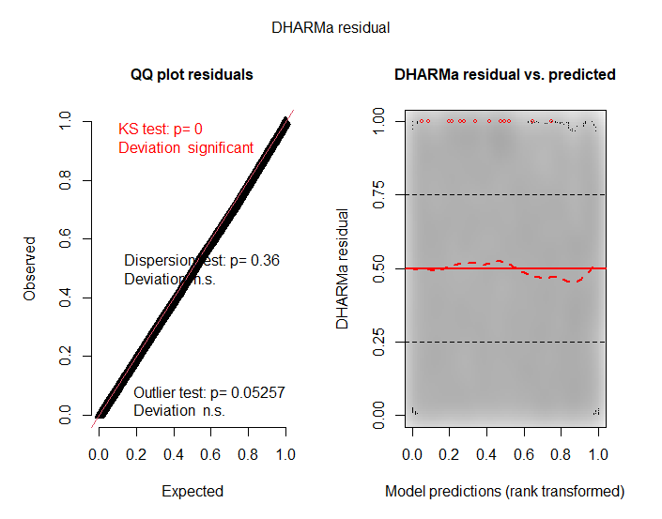

**Figure X-2**  
DHARMa Residual Diagnostics for the Spatial–Spatiotemporal Model

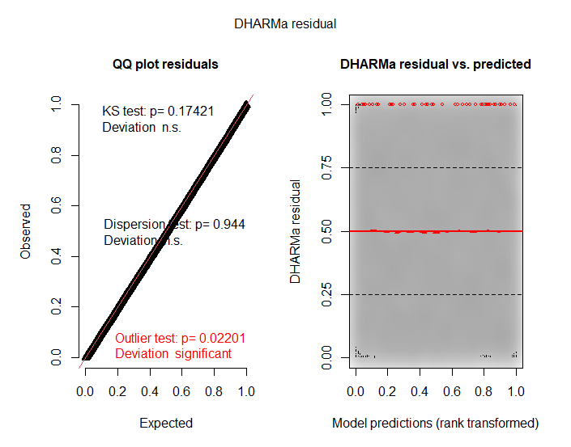

Model diagnostics using the DHARMa package indicated differences in residual fit between the generalized linear mixed model (GLMM) and the spatial–spatiotemporal sdmTMB model. For the GLMM, the Kolmogorov–Smirnov (KS) test for uniformity of residuals was statistically significant, p<.001p < .001p<.001, indicating a deviation from the expected distribution. In contrast, the sdmTMB model’s KS test was non-significant (p=.174p = .174p=.174), suggesting adequate residual uniformity. Dispersion tests were non-significant for both models (GLMM: p=.360p = .360p=.360; sdmTMB: p=.944p = .944p=.944), indicating no evidence of overdispersion. Outlier tests were non-significant in both models (GLMM: p=.053p = .053p=.053; sdmTMB: p=.022p = .022p=.022), although the sdmTMB model showed a small but significant deviation at the 5% level. Visual inspection of the residual–predicted plots revealed a mild pattern in the GLMM residuals, particularly at mid-range predicted values, whereas the sdmTMB residuals appeared more evenly distributed. Collectively, these results suggest that incorporating spatial and spatiotemporal random effects via the sdmTMB framework improved the overall model fit and reduced systematic residual deviations relative to the GLMM.

Next Steps:

1. Address the Outlier Test Issue

**Appendix A**

Table A1. Global Moran’s I of ER Visits (Total and Per Capita)

|  |  |  |
| --- | --- | --- |
|  |  | Per Capita |
| Moran's Index |  | 0.206 |
| Expected Index |  | -0.048 |
| Variance |  | 0.035 |
| z-score |  | 1.355 |
| p-value |  | 0.175 |

Figure A1. Hot Spot Analysis (Geti-Ord Gi*) of ER Visits (Total and Per Capita)

*****

(a) Total ER Visits (b) Per Capita ER Visits

A closer examination of total ER visit counts (Figure 6(a)) reveals a potential hot spot in Jefferson and Shelby counties. However, this clustering is likely influenced by the high population density in these areas. In contrast, using per capita data, Figure 6(b) shows that Colbert, Franklin, and Lawrence counties exhibited increasing trends in ER visits, while Pickens and Madison counties demonstrated a decreasing pattern. Despite these localized variations, Moran’s I was not statistically significant for either total or per capita ER visits, indicating no strong spatial autocorrelation overall.

**Appendix B**

Figure B1. Monthly Buprenorphine Consumption by County

Figure B1 shows that a consistent upward trend of monthly Buprenorphine consumption is evident in most counties. This increase suggests a regional shift toward buprenorphine as a preferred opioid treatment option, potentially driven by expanding treatment programs or increased awareness of medication-assisted therapy. While urban counties reported the highest per capita use, even rural areas such as Marion, Franklin, and Lawrence exhibited gradual increases. These results support the hypothesis that buprenorphine availability and uptake have grown substantially across northwest Alabama during the study period.

In contrast, Morgan County stands out as an exception. Unlike the general upward trajectory, buprenorphine consumption in Morgan County remained relatively flat throughout the study period. This stagnation may point to limited provider availability, regulatory barriers, or differences in local treatment infrastructure that warrant further investigation.

Figure B2. Hot Spot Analysis (Geti-Ord Gi*) of Medication Consumption (Total)

(a) Buprenorphine (b) Hydrocodone

(c) Methadone (d) Oxycodone

Figure B2 (a) presents the spatial consumption of Buprenorphine consumption across northwest Alabama counties. The map reveals a distinct concentration of higher consumption in Jefferson and Shelby counties, shown in dark red, indicating that these areas had the most substantial usage during the study period. Walker County, in a lighter red shade, also demonstrates moderately elevated consumption. In contrast, the remaining counties are displayed in light gray, signifying lower or negligible levels of Buprenorphine use. This pattern suggests that Buprenorphine treatment was more accessible or more widely utilized in metropolitan areas such as Jefferson and Shelby, possibly due to the presence of more healthcare providers or greater treatment-seeking populations. These findings may reflect regional differences in access to medication-assisted treatment (MAT) services and underscore the need to investigate disparities in treatment availability and uptake across rural and urban contexts. In Figure x, we also present the spatial consumption of the other three opioid medications for comparison. Although the Moran’s I statistics for these drugs were not statistically significant, the maps still reveal notable concentrations of consumption in Jefferson and Shelby counties.

Figure 9. Monthly Methadone Per Capita Consumption by County

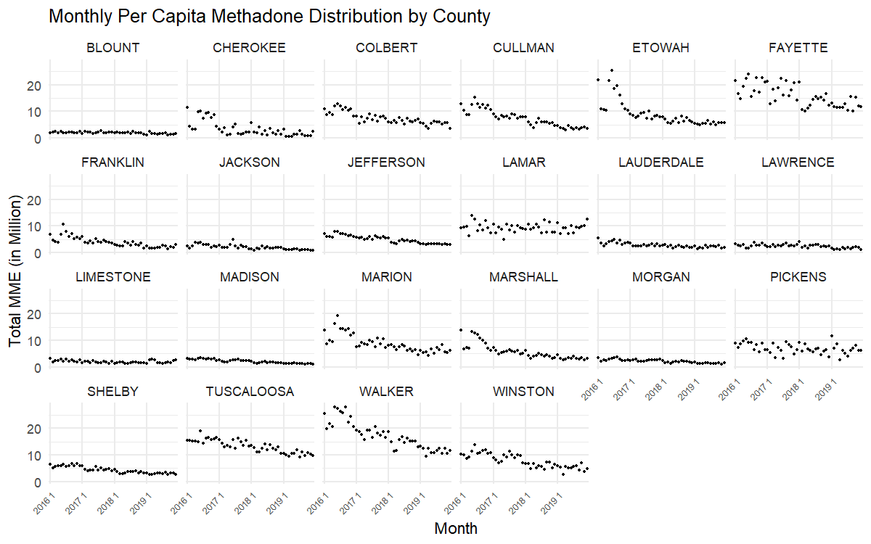

Figure 9 illustrates declining monthly methadone consumption trends across most counties in northwest Alabama exhibited. High-use counties such as Etowah and Marshall showed substantial decreases over time, suggesting possible policy changes, treatment shifts, or public health interventions targeting methadone-related opioid dependency. Jefferson and Tuscaloosa counties, despite their larger populations, maintained moderate and stable per-capita consumption patterns with slight downward slopes. Meanwhile, counties such as Lamar and Pickens demonstrated relatively steady trends, with minor fluctuations and no pronounced decline. The widespread reduction in methadone consumption may reflect a regional move away from methadone in favor of other medication-assisted treatments (e.g., buprenorphine), or increased regulation and monitoring of opioid prescriptions in the area.

Figure 10. Hot Spot Analysis (Geti-Ord Gi*) of Medication Consumption (Per Capita)

(a) Buprenorphine (b) Hydrocodone

(c) Methadone (d) Oxycodone

Figure 10 (c) illustrates the spatial clustering of methadone consumption per capita using Getis-Ord Gi* statistics. The results identify a significant hot spot in the southwestern portion of the region, particularly in Tuscaloosa, Fayette, Walker, and Lamar counties. This suggests that residents in these counties have higher access to or greater utilization of methadone treatment programs, potentially reflecting localized public health strategies or higher opioid dependence treatment demand. Conversely, a cold spot cluster comprising Madison, Limestone, and Morgan counties may indicate limited methadone consumption, possibly due to policy, access, or demographic factors.

Although the Global Moran’s I values for hydrocodone, methadone, and oxycodone were not statistically significant (p > 0.05), we still offer the hot spot figure for reference (Figure 10 (a), (b), and (d)).